Project Design Phase-II Technology Stack (Architecture & Stack)

Date Team ID

Project Name

29 October 2022 PNT2022TMID25832

Smart Solution for Railways

**Technical Architecture:**

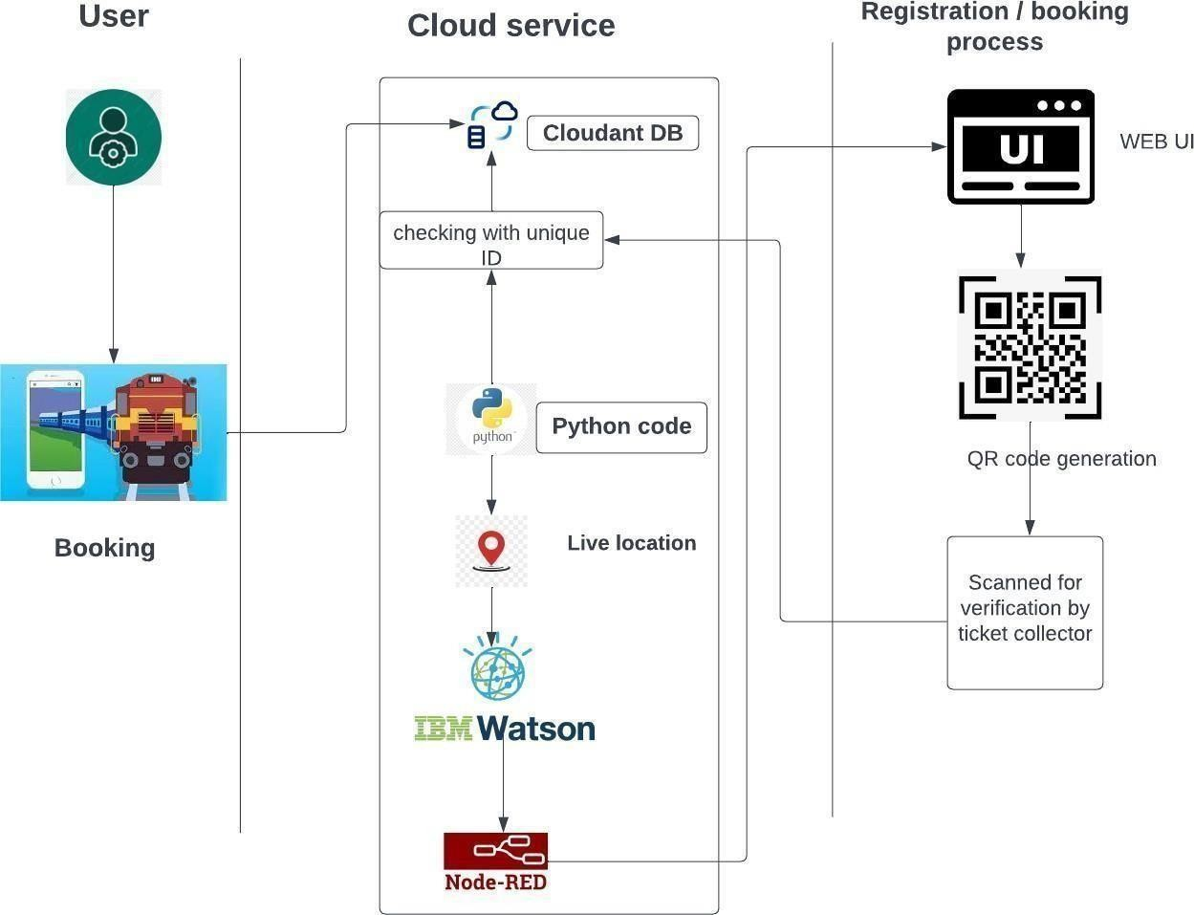

**Table-1 : Components & Technologies:**

**S.No**

**Component**

**Description**

**Technology**

1. Web UI

User can login and book their ticket through the website based on the availability of the seats.

HTML, CSS, JavaScript

1. Cloud Services

Requirements filled by the passenger is stored in the cloud database.

Python

1. GPS Tracking

Live Location details shared through the code to share the location in the website

IBM Watson Service

1. External API-1

Used for rail schedule, ticketing and travel documents generation, cancellation.

Sabre API

1. External API-2

Used for combining carriers and ticket types, Multilanguage & currency support.

Trainline B2B API

1. Data Processing

Ticket is verified with the unique ID generated with the cloudland DB

Python, IBM cloud

**S.No Characteristics**

**Description**

**Technology**

1. Open-Source Frameworks

CSS, Backend framework,

Python, IBM cloudant DB

2. Security Implementations

Data entered are encrypted, Continuous Location Tracking

Python, Cloud service

3. Scalable Architecture

The scanner and the codes written are highly scalable where any implementation can be done anytime needed

Python

4. Availability

Any time available system. The ticket can be verified IBM Load Balancer by the ticket collector from anywhere.

5. Performance

Though the details are get stored in the cloud the Distributed Services, GPS Tracker system crash will not affect the data. The data can

be retrieved from anywhere with a scanner. And the GPS states the exact location of the train.

**Table-2: Application Characteristics:**